Internship Report - Day 2
Name : Rickshtiha A
Intern ID : CDM/INT/202607608
Topic: Python Basics

Objective
The objective of Day 2 was to learn the fundamentals of Python programming, including variables, data types, operators, conditional statements, loops, and functions. The session also focused on writing simple Python programs to strengthen basic programming skills.

Tasks Completed
- Learned Python variables.
- Understood different Python data types.
- Practiced arithmetic, comparison, logical, and assignment operators.
- Learned conditional statements (if, elif, else).
- Practiced loops (for and while).
- Learned how to create and call functions.
- Wrote and executed simple Python programs.

Topics Learned
1. Variables
Variables are used to store data values.
Example
name = "Rickshitha"
age = 19

2. Data Types
Python supports different data types such as:
- Integer (int)
- Float (float)
- String (str)
- Boolean (bool)
- List (list)
- Tuple (tuple)
- Dictionary (dict)
Example
name = "Rickshitha"
age = 19
marks = 89.5
is_student = True

3. Operators
The following operators were practiced:
- Arithmetic Operators
- Comparison Operators
- Logical Operators
- Assignment Operators
Example
a = 10
b = 5

print(a + b)
print(a > b)

4. Conditional Statements
Conditional statements help make decisions.
Example
age = 18

if age >= 18:
print("Eligible to Vote")
else:
print("Not Eligible")

5. Loops
For Loop
for i in range(1, 6):
print(i)
While Loop
count = 1

while count <= 5:
print(count)
count += 1

6. Functions
Functions help reuse code.
Example
def greet(name):
print("Hello", name)

greet("Rickshitha")

Programs Practiced
Program 1 – Addition of Two Numbers
a = 10
b = 20

print("Sum =", a + b)
Program 2 – Even or Odd
num = int(input("Enter a number: "))

if num % 2 == 0:
print("Even")
else:
print("Odd")
Program 3 – Multiplication Table
num = 5

for i in range(1, 11):
print(num, "x", i, "=", num * i)
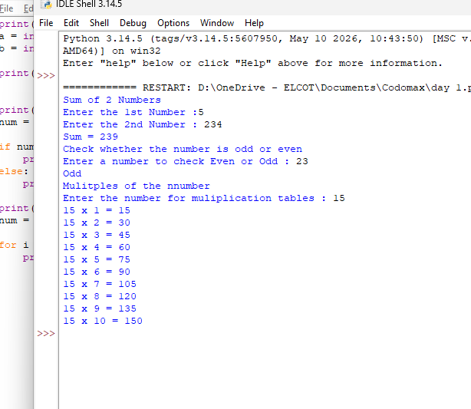

Learning Outcome
Day 2 provided a strong foundation in Python programming. I gained practical experience in writing simple programs using variables, operators, loops, conditional statements, and functions. These concepts will serve as the basis for developing more advanced AI and Machine Learning applications in the upcoming sessions.

